**COMPSOFT TECHNOLOGIES**

Bengaluru, Karnataka, India



AN INTERNSHIP REPORT

ON

“MADE 4 U”

#### Bachelor of Engineering

#### In

#### Information Science and Engineering

#### 

#### Submitted by: NEHAL MODI (1MV18IS034)

#### MIHIR ARYAN (1MV18IS029)

#### 

#### 

**SIR M VISVESVARAYA INSTITUTE OF TECHNOLOGY**

#### 2021

## ABOUT THE COMPANY

M4Y is a digital service provider that aims to provide software, designing and marketing solutions to individuals and businesses.

At M4Y, it is believed that service and quality is the key to success.

Founded and Funded by Graphic designers from Jahirathu Junction, M4Y has now set a new path towards Digital Solutions.

Some of our services include:

Development - We develop responsive, functional and super-fast websites.

We keep User Experience in mind while creating websites. A website should load quickly and should be accessible even on a small view-port and slow internet connection.

Mobile Application - We offer a wide range of professional Android, iOS & Hybrid app development services for our global clients, from a start up to a large enterprise.

Design - We offer professional Graphic design, Brochure design & Logo design. We are experts in crafting visual content to convey the right message to the customers.

Consultancy - We are here to provide you with expert advice on your design and development requirement.

Videos - We create a polished professional video that impresses your audience.

**TABLE OF CONTENTS**

Table of contents i

Overview of the Project 1

About MADE 4 U 2

Project Description 3

Tools Used 5

Implementation 6

Snapshots 40

Bibliography 50

## OVERVIEW OF THE PROJECT

## Project Name: MADE 4 U

**Team Members:** NEHAL MODI

**MIHIR ARYAN**

This project is based on Web Development And its Applications. The main objective of this project is to learn the implementation of HTML, CSS and JavaScript. The basic webpage of this project is created using HTML and styling of the webpage is done using CSS.The backend is done using php and My sql.

This webpage is about providing software,designing and marketing solutions to individuals and businesses.this is a website which is designed to develop responsive, functional and super-fast websites.It is a Creative web solutions blended with latest technologies form the right base for innovative businesses.It also provides mobility and security.We have created more than 2,000 websites and are working on 500 more projects. CST, core strength lies in our super energetic and gigantic team, forming an excellent blend of IT minds along with a creative bent.

## ABOUT MADE 4 U

This is a digital service provider that aims to provide software, designing and marketing solutions to individuals and businesses.

At CST, it is believed that service and quality is the key to success. Founded and Funded by Graphic designers from Jahirathu Junction,

CST has now set a new path towards Digital Solutions.

Software publishing, consultancy and supply [Software publishing includes production, supply and documentation of ready-made

(non-customized) software, operating systems software, business & other applications software, computer games software for all

platforms. Consultancy includes providing the best solution in the form of custom software after analyzing the user?s needs and

problems. Custom software also includes made-to-order software based on orders from specific users. Also, included are writing of

software of any kind following directives of the users; software maintenance, web-page design].

We have a proven record of building highly scalable, world-class consulting processes that offer tremendous business advantages

to our clients in the form of huge cost-benefits, definitive results and consistent project deliveries across the globe.

## DESCRIPTION

Our ability to conceive and deliver superior digital service is based on the expertise and the processes

we have developed this project strategically planning, designing, developing and implementing sophisticated.

There are usually many different people and resources required to bring a project from inception to conclusion.

Coordinating and managing these people, resources and the various processes required to develop successful web sites

is an area of strategic focus and differentiation for CST and its web development team.

This section of the proposal describes an approach that we would take to define and document the requirements of the

project and develop, test and launch the new site.

**Project Steps**

All of our projects are organized into four distinct steps, each of which is outlined below.

**Step 1: Discovery & Design**

All of our projects are organized into four distinct steps, each of which is outlined below. In this step of the project

we are primarily interested in working closely with the CLIENT stakeholders to further discover and clearly define the

functional and business requirements for the new web site. During this phase of the project we begin to design the site

both graphically from a look and feel perspective, as well as architecturally from a technical, database and navigation perspective.

Everything would be documented and agreed upon prior to beginning development. And because CLIENT is intimately involved in these

design and discovery meetings, you will have excellent insight as to how things are to progress and most importantly you will be an

integral part of the entire design process.

We will also document the following kinds of information (there may be other items to determine):

1) The profile of the target audiences

2) Define and document the new site map (navigational layout / content organization) of the web site

3) Define and document the product catalog categories and sub categories

4) Define and document the common and unique attributes of all product categories

5) Define and document the work flow associated with

i) Home page containing all information of the company.

ii) Service page containing the services provided by the company.

iii) Our work page containing the work details done by the company.

iv) contact us page where customer contact with the company through sending the problem they arefacing.

**Step 2: Creative & Application Development**

In Step 1 of the approach all of the specific requirements for the new web site have been determined.

In Step 2 we engage in two parallel streams of activity.

he first stream is the Creative Development Process where the project team works together to produce two distinct

creative design concepts, which are reviewed and critiqued by the CLIENT stakeholders.

These will be further refined by CST designers based on feedback in an iterative and interactive process until a final concept is chosen by the CLIENT.

Once the final design concept is chosen, group member produces all of the required graphics, HTML and CSS templates necessary to build out the entire web site.

The HTML pages (PHP and mysql) are produced.

The second stream is the Development Process where the developer programs all of the functional aspects of the web site and works closely with the group

members to integrate the creative with the functionality.

**Step 3: System & User Acceptance Testing**

In Step 2 the entire web site has been developed based on the requirements discovered and documented in Step 1.

In Step 3 we release the new web site to our internal System for Testing; to validate the application as

developed has met all of the requirements as documented in Step 1.

# TOOLS USED

### Software Requirements

* Visual Studio Code 2019.
* Google Chrome or Microsoft Edge of latest version.
* Front End: HTML, CSS, BOOTSTRAP,JS
* Back End: PHP,MY SQL
* Windows 10 OS

### Hardware Requirements

* Pentium 200-MHz computer with a minimum of 64 MB of RAM (128 MB of RAM recommended).
* Monitor with a refresh rate of at least 40Hz for a smooth GUI experience (optional).

# IMPLEMENTATION

# Source Code (index.html):

<!DOCTYPE html>

<html lang="en">

<head>

    <title>Made4you Pvt Ltd</title>

    <meta charset="utf-8">

    <meta name="viewport" content="width=device-width, initial-scale=1">

    <link rel="stylesheet" type="text/css" href="css/style.css">

    <link href="https://fonts.googleapis.com/css?family=Poppins&display=swap" rel="stylesheet">

    <link rel="stylesheet" href="https://cdnjs.cloudflare.com/ajax/libs/font-awesome/4.7.0/css/font-awesome.min.css"

        integrity="sha512-SfTiTlX6kk+qitfevl/7LibUOeJWlt9rbyDn92a1DqWOw9vWG2MFoays0sgObmWazO5BQPiFucnnEAjpAB+/Sw=="

        crossorigin="anonymous" referrerpolicy="no-referrer" />

    <link rel="stylesheet" href="https://use.fontawesome.com/releases/v5.0.7/css/all.css">

    <link rel="stylesheet" href="https://maxcdn.bootstrapcdn.com/bootstrap/4.5.2/css/bootstrap.min.css">

</head>

<body>

    <!--------------------------Header part start here------------------------------------->

    <div class="header" id="topheader">

        <nav class="navbar navbar-expand-lg navbar-dark fixed-top">

            <div class="container text-uppercase  p-2">

                <img class="aaaaaa" src="images/our-official-logo.png">

                <a class="navbar-brand font-weight-bold text-white" href="#">&emsp;Compsoft Technologies</a>

                <button class="navbar-toggler" type="button" data-toggle="collapse"

                    data-target="#navbarSupportedContent" aria-controls="navbarSupportedContent" aria-expanded="false"

                    aria-label="Toggle navigation">

                    <span class="navbar-toggler-icon"></span>

                </button>

                <div class="collapse navbar-collapse" id="navbarSupportedContent">

                    <ul class="navbar-nav ml-auto text-uppercase">

                        <li class="nav-item active">

                            <a class="nav-link" href=index.html>Home <span class="sr-only">(current)</span></a>

                        </li>

                        <li class="nav-item">

                            <a class="nav-link" href=service.html>service</a>

                        </li>

                        </li>

                        <li class="nav-item">

                            <a class="nav-link" href=work.html>OUR work</a>

                        </li>

                        <li class="nav-item">

                            <a class="nav-link" href=contact.html>Contact</a>

                        </li>

                    </ul>

                </div>

            </div>

        </nav>

        <section class="header-section">

            <div class="center-div">

                <h1 class="font-weight-bold">AN EXCLUSIVE WEBSITE FOR YOU</h1>

                <p> We love what we do and we do what our clients love

                    <br>and work with great clients all over the world to

                    <br>create thoughtful and purposeful websites.

                </p>

                <div class="header-buttons">

                    <a href="#footerdiv">About Us</a>

                    <a href="#footerdiv">Contact</a>

                </div>

            </div>

        </section>

    </div>

    <!--------------------------Header part end here------------------------------------->

    <!--------------------------Three extra header div start------------------------------------->

    <section class="header-extradiv">

        <div class="container">

            <div class="row">

                <div class="extra-div col-lg-4 col-md-4 col-12">

                    <a href="#"><i class="fa-3x fas fa-desktop" aria-hidden="true">

                        </i></a>

                    <h2>Web Development</h2>

                    <p>Creative web solutions blended with latest technologies form the right base for innovative

                        businesses.</p>

                </div>

                <div class="extra-div col-lg-4 col-md-4 col-12">

                    <a href="#"><i class="fa-3x fas fa-shield-alt aria-hidden=" true">

                        </i></a>

                    <h2> Security</h2>

                    <p>Our Cyber Security Consulting back your organization with years of experience working on projects

                        for some of the world’s largest organizations.</p>

                </div>

                <div class="extra-div col-lg-4 col-md-4 col-12">

                    <a href="#"><i class="fa-3x fas fa-magic" aria-hidden="true">

                        </i></a>

                    <h2> Mobility</h2>

                    <p>We believe that the look of a website or mobile app is as important as it’s functioning.So we

                        make sure to design the app that looks nice and functions well and runs stable on your device.

                    </p>

                </div>

            </div>

        </div>

    </section>

    <!--------------------------Three extra header div end------------------------------------->

    <!--------------------------Project start------------------------------------->

    <section class="project-work">

        <div class="container headings text-center">

            <br>

            <P class="text-center font-weight=bold">MORE THAN 2,000 WEBSITES CREATED</P>

        </div>

        <div class="container d-flex justify-content-around align-items-center text-center">

            <div>

                <h1 class="count">1500</h1>

                <p>Awards Won</p>

            </div>

            <div>

                <h1 class="count">2500</h1>

                <p>CMS Installation</p>

            </div>

            <div>

                <h1 class="count">700</h1>

                <p>Happy clients</p>

            </div>

            <div>

                <h1 class="count">500</h1>

                <p>Working on</p>

            </div>

        </div>

    </section>

    <!--------------------------Project done end------------------------------------->

    <!--------------------------our pricing start------------------------------------->

    <section class="pricing" id="pricingdiv">

        <div class="container headings text-center">

            <h1 class="text-center font-weight=bold text-white">WHY COMPSOFT TECHNOLOGIES??</h1>

        </div>

        <div class="container">

            <div class="row">

                <div class="col-lg-4 col-12">

                    <div class="card text-center">

                        <div class="card-header">Mobility</div>

                        <div class="card-body">

                            <a href="#"><i class="fa-5x fas fa-magic" aria-hidden="true"></i></a>

                            <br><br>

                            <p class="ourprice">CST, core strength lies in our super energetic and gigantic team,

                                forming an excellent blend of IT minds along with a creative bent.<br>Our endeavour is

                                to continuously improve and deliver maximum–enriching products & solutions. That’s what

                                we mean – doing IT better driving business transformation, digitally – Applying

                                disruptive technologies for business transformations.<br>CST brings great advantage to

                                business space by bridging gaps, simplifying businesses and elevating competitive

                                benefits by providing technology-based business solutions.</p>

                        </div>

                        <!-- <div class="card-footer">

                    </div> -->

                    </div>

                </div>

                <div class="col-lg-4 col-12 card-second">

                    <div class="card text-center">

                        <div class="card-header">Cloud Computing</div>

                        <div class="card-body">

                            <a href="#"><i class="fa-5x fas fa-cloud" aria-hidden="true"></i></a>

                            <br><br>

                            <p class="ourprice">Leveraging the enormous talent of our passionate and proven individuals.

                                We are hugely a customer-centric organization that is bent upon consummating the needs

                                of the customers beyond their expectations. We successfully host a consortium of

                                experienced professionals who work in synergy in order to gain an edge over the market.

                                we look at ourselves as a team where we co-create with them.</p>

                        </div>

                        <!-- <div class="card-footer">

                    </div> -->

                    </div>

                </div>

                <div class="col-lg-4 col-12">

                    <div class="card text-center">

                        <div class="card-header">Security</div>

                        <div class="card-body">

                            <a href="#"><i class="fa-5x fas fa-shield-alt" aria-hidden="true"></i></a>

                            <br><br>

                            <p class="ourprice">Having delivered successful projects we pride ourselves on being a

                                sought-after mobile application development. We truly believe that our customer's

                                success is our success We don’t look at ourselves as a vendor for their projects

                                instead. You would be excited to hear some of our stories and know to what extent we

                                have gone in the interest of the success of our customers. and we work hard to make that

                                happen. This philosophy and execution have resulted in a long-term partnership with most

                                of our clients, where we keep contributing to their solutions year after year.</p>

                        </div>

                        <!-- <div class="card-footer">

                    </div> -->

                    </div>

                </div>

            </div>

        </div>

    </section>

    <!--------------------------our pricing end------------------------------------->

    <!---------------------------- our customers feedback start--------------------->

    <section class="happyclients" id="pricingdiv">

        <div class="container headings text-center">

            <br><br><br><br><br><br><br>

            <h1 class="text-center font-weight=bold ">OUR HAPPY CLIENTS</h1>

            <P class="text-capitalize pt-1">Our Satisfied Customer Says</P>

        </div>

        <div id="demo" class="carousel slide" data-ride="carousel">

            <!-- Indicators -->

            <ul class="carousel-indicators">

                <li data-target="#demo" data-slide-to="0" class="active"></li>

                <li data-target="#demo" data-slide-to="1"></li>

                <li data-target="#demo" data-slide-to="2"></li>

            </ul>

            <!-- The slideshow -->

            <div class="carousel-inner container">

                <div class="carousel-item active">

                    <div class="row">

                        <div class="col-lg-4 col-md-4 col-12">

                            <div class="box">

                                <a href="#"><img src="images/header-bg.jpg" class="img-fluid img-thumbnail"></a>

                                <p class="m-4">It is a distinct pleasure for me to recommend CST to any and all

                                    interested parties</p>

                                <h1>STEVE JAMES</h1>

                                <h2>Web Developer</h2>

                            </div>

                        </div>

                        <div class="col-lg-4 col-md-4 col-12">

                            <div class="box">

                                <a href="#"><img src="images/header-bg.jpg" class="img-fluid img-thumbnail"></a>

                                <p class="m-4">Having new website built by CST, we have seen a 200% increase in the

                                    number of online contact forms being filled out .</p>

                                <h1>BREDEN BIEN</h1>

                                <h2>Web Developer</h2>

                            </div>

                        </div>

                        <div class="col-lg-4 col-md-4 col-12">

                            <div class="box">

                                <a href="#"><img src="images/header-bg.jpg" class="img-fluid img-thumbnail"></a>

                                <p class="m-4">With CST’s help, we were able to increase the functionality of our

                                    website dramatically while cutting our costs.</p>

                                <h1>DAVID DRAKE</h1>

                                <h2>Web Developer</h2>

                            </div>

                        </div>

                    </div>

                </div>

                <div class="carousel-item">

                    <div class="row">

                        <div class="col-lg-4 col-md-4 col-12">

                            <div class="box">

                                <a href="#"><img src="images/header-bg.jpg" class="img-fluid img-thumbnail"></a>

                                <p class="m-4">I would highly recommend CST. They are great to work with.It was an

                                    awesome experience </p>

                                <h1>Mark LUIS</h1>

                                <h2>Web Developer</h2>

                            </div>

                        </div>

                        <div class="col-lg-4 col-md-4 col-12">

                            <div class="box">

                                <a href="#"><img src="images/header-bg.jpg" class="img-fluid img-thumbnail"></a>

                                <p class="m-4">CST excels at turning your website dreams into reality. We are so proud

                                    of the work they’ve done for us</p>

                                <h1>Sant LU</h1>

                                <h2>Web Developer</h2>

                            </div>

                        </div>

                        <div class="col-lg-4 col-md-4 col-12">

                            <div class="box">

                                <a href="#"><img src="images/header-bg.jpg" class="img-fluid img-thumbnail"></a>

                                <p class="m-4">I have had many websites since the early 90s. Most were like pulling

                                    teeth to get developed. Not so with the CST team</p>

                                <h1>CHRIST MIKE</h1>

                                <h2>Web Developer</h2>

                            </div>

                        </div>

                    </div>

                </div>

                <div class="carousel-item ">

                    <div class="row">

                        <div class="col-lg-4 col-md-4 col-12">

                            <div class="box">

                                <a href="#"><img src="images/header-bg.jpg" class="img-fluid img-thumbnail"></a>

                                <p class="m-4">The attention to detail with CST’s professional staff is incredible. The

                                    entire team has proven to be very innovative .</p>

                                <h1>REA SOLVANKI</h1>

                                <h2>Web Developer</h2>

                            </div>

                        </div>

                        <div class="col-lg-4 col-md-4 col-12">

                            <div class="box">

                                <a href="#"><img src="images/header-bg.jpg" class="img-fluid img-thumbnail"></a>

                                <p class="m-4">We re-did our website twice in a 12 month period. There was no comparison

                                    between the first company and CST.</p>

                                <h1>TONY ROUTIGLANO<< /h1>

                                        <h2>Web Developer</h2>

                            </div>

                        </div>

                        <div class="col-lg-4 col-md-4 col-12">

                            <div class="box">

                                <a href="#"><img src="images/header-bg.jpg" class="img-fluid img-thumbnail"></a>

                                <p class="m-4">We have been very happy with our new website! It looks professional and

                                    very easy to navigate.</p>

                                <h1>MELLISA MONTEL</h1>

                                <h2>Web Developer</h2>

                            </div>

                        </div>

                    </div>

                </div>

            </div>

            <!-- Left and right controls -->

            <a class="carousel-control-prev" href="#demo" data-slide="prev">

                <span class="carousel-control-prev-icon"></span>

            </a>

            <a class="carousel-control-next" href="#demo" data-slide="next">

                <span class="carousel-control-next-icon"></span>

            </a>

        </div>

    </section>

    <!---------------------------- our customers feedback end--------------------->

    <!---------------------------- footer start--------------------->

    <br><br><br><br>

    <footer class="footersection" id="footerdiv">

        <div class="container">

            <div class="row">

                <div class="col-lg-4 col-md-6 col-12 footer-div">

                    <div>

                        <h3>ABOUT COMPSOFT TECHNOLOGIES</h3>

                        <P>This is a digital service provider that aims to provide software,

                            designing and marketing solutions to individuals and

                            businesses. At CST, it is believed that service and quality is the

                            key to success. Founded and Funded by Graphic designers

                            from Jahirathu Junction, CST has now set a new path towards

                            Digital Solutions.</P>

                    </div>

                </div>

                <div class="col-lg-4 col-md-6 col-12 footer-div text-center">

                    <div>

                        <h3>NAVIGATION LINK</h3>

                        <li><a href=index.html>HOME</a></li>

                        <li><a href=service.html>SERVICE</a></li>

                        <li><a href="#">OUR WORK</a></li>

                        <li><a href=contact.html>CONTACT</a></li>

                    </div>

                </div>

                <div class="col-lg-4 col-md-12 col-12 footer-div text-center">

                    <div>

                        <h3>Contact us</h3>

                        <P>Click on the link below to contact us!! </P>

                        <div class="header-buttons">

                            &emsp14;<br><a href=contact.html>Contact</a></div>

                    </div>

                </div>

            </div>

            <div class="mt-5 text-center">

                <p>Copyright @2021 All rights reserved</p>

            </div>

            <div class="scrolltop float-right">

                <i class="fas fa-arrow-up" onclick="topFunction()" id="myBtn"></i>

            </div>

        </div>

    </footer>

    <!---------------------------- footer end--------------------->

    <a href="https://wa.me/country_code_and_your_phone_number" class="whatsapp_float" target="_blank"> <i

            class=" fa-2x fab fa-whatsapp-square"></i></a>

    <!-- scripting-->

    <script src="https://ajax.googleapis.com/ajax/libs/jquery/3.5.1/jquery.min.js"></script>

    <script src="https://cdnjs.cloudflare.com/ajax/libs/waypoints/4.0.1/jquery.waypoints.min.js"

        integrity="sha512-CEiA+78TpP9KAIPzqBvxUv8hy41jyI3f2uHi7DGp/Y/Ka973qgSdybNegWFciqh6GrN2UePx2KkflnQUbUhNIA=="

        crossorigin="anonymous" referrerpolicy="no-referrer"></script>

    <script src="https://cdnjs.cloudflare.com/ajax/libs/Counter-Up/1.0.0/jquery.counterup.min.js"

        integrity="sha512-d8F1J2kyiRowBB/8/pAWsqUl0wSEOkG5KATkVV4slfblq9VRQ6MyDZVxWl2tWd+mPhuCbpTB4M7uU/x9FlgQ9Q=="

        crossorigin="anonymous" referrerpolicy="no-referrer"></script>

    <script src="https://cdnjs.cloudflare.com/ajax/libs/popper.js/1.16.0/umd/popper.min.js"></script>

    <script src="https://maxcdn.bootstrapcdn.com/bootstrap/4.5.2/js/bootstrap.min.js"></script>

    <script>

        $('.count').counterUp({

            delay: 10,

            time: 3000

        })

        //Get the button:

        mybutton = document.getElementById("myBtn");

        //when the user scrolls down 20px from the top of the document,show the button

        window.onscroll = function () { scrollFunction() };

        function scrollFunction() {

            if (document.body.scrollTop > 20 || document.documentElement.scrollTop > 20) {

                mybutton.style.display = "block";

            } else {

                mybutton.style.display = "none";

            }

        }

        //when the user clicks on the button, scroll to the top of the document

        function topFunction() {

            document.body.scrollTop = 0;// For safari

            document.documentElement.scrollTop = 0;//for chrome,firefox,ie, opera

        }

    </script>

</body>

</html>

# Source Code (service.html):

<!DOCTYPE html>

<html lang="en">

<head>

    <title>Made4you Pvt Ltd | service</title>

    <meta charset="utf-8">

    <meta name="viewport" content="width=device-width, initial-scale=1">

    <link rel="stylesheet" type="text/css" href="css/style.css">

    <link href="https://fonts.googleapis.com/css?family=Poppins&display=swap" rel="stylesheet">

    <link rel="stylesheet" href="https://cdnjs.cloudflare.com/ajax/libs/font-awesome/4.7.0/css/font-awesome.min.css"

        integrity="sha512-SfTiTlX6kk+qitfevl/7LibUOeJWlt9rbyDn92a1DqWOw9vWG2MFoays0sgObmWazO5BQPiFucnnEAjpAB+/Sw=="

        crossorigin="anonymous" referrerpolicy="no-referrer" />

    <link rel="stylesheet" href="https://use.fontawesome.com/releases/v5.0.7/css/all.css">

    <link rel="stylesheet" href="https://maxcdn.bootstrapcdn.com/bootstrap/4.5.2/css/bootstrap.min.css">

</head>

<body>

    <!--------------------------Header part start here------------------------------------->

    <div class="header" id="topheader">

        <nav class="navbar navbar-expand-lg navbar-dark fixed-top">

            <div class="container text-uppercase  p-2">

                <img class="aaaaaa" src="images/our-official-logo.png">

                <a class="navbar-brand font-weight-bold text-white" href="#">&emsp;Compsoft Technologies</a>

                <button class="navbar-toggler" type="button" data-toggle="collapse"

                    data-target="#navbarSupportedContent" aria-controls="navbarSupportedContent" aria-expanded="false"

                    aria-label="Toggle navigation">

                    <span class="navbar-toggler-icon"></span>

                </button>

                <div class="collapse navbar-collapse" id="navbarSupportedContent">

                    <ul class="navbar-nav ml-auto text-uppercase">

                        <li class="nav-item active">

                            <a class="nav-link" href=index.html>Home <span class="sr-only">(current)</span></a>

                        </li>

                        <li class="nav-item">

                            <a class="nav-link" href=service.html>service</a>

                        </li>

                        </li>

                        <li class="nav-item">

                            <a class="nav-link" href=work.html>OUR work</a>

                        </li>

                        <li class="nav-item">

                            <a class="nav-link" href=contact.html>Contact</a>

                        </li>

                    </ul>

                </div>

            </div>

        </nav>

        <section class="header-section">

            <div class="center-div">

                <h1 class="font-weight-bold">SERVICES</h1>

            </div>

        </section>

    </div>

    <!--------------------------Header part end here------------------------------------->

    <!--------------------------content start------------------------------------->

    <br><br><br>

    <section class="pricing" id="pricingdiv">

        <div class="container headings text-center">

            <h1 class="text-center font-weight=bold text-white">OUR SERVICES</h1>

        </div>

        <div class="container">

            <div class="row">

                <div class="col-lg-4 col-12">

                    <div class="card text-center">

                        <div class="card-header">DEVELOPMENT</div>

                        <div class="card-body">

                            <img src="images/development.jpg">

                            <br><br>

                            <p class="ourprice">We develop responsive, functional and super-fast websites.

                                We keep User Experience in mind while creating websites. A website should load

                                quickly and should be accessible even on a small view-port and slow internet

                                connection</p>

                        </div>

                    </div>

                </div>

                <div class="col-lg-4 col-12 card-second">

                    <div class="card text-center">

                        <div class="card-header">Consultancy</div>

                        <div class="card-body">

                            <img src="images/consultancy.jpg">

                            <br><br>

                            <p class="ourprice">We are here to provide you with expert advice on your design and

                                development requirements.</p><br><br><br>

                        </div>

                    </div>

                </div>

                <div class="col-lg-4 col-12">

                    <div class="card text-center">

                        <div class="card-header">VIDEOS</div>

                        <div class="card-body">

                            <img src="images/videos.png">

                            <br><br>

                            <p class="ourprice"><br><br>We create a polished professional video that impresses your

                                audience.<br><br><br></p>

                        </div>

                    </div>

                </div>

            </div>

        </div>

    </section>

    <!--------------------------content end------------------------------------->

    <!--------------------------content 2 start------------------------------------->

    <br><br><br><br><br><br>

    <section class="pricing" id="pricingdiv">

        <div class="container headings text-center">

        </div>

        <div class="container">

            <div class="row">

                <div class="col-lg-4 col-12">

                    <div class="card text-center">

                        <div class="card-header">CONTENT WRITING</div>

                        <div class="card-body">

                            <img src="images/content.png">

                            <br><br>

                            <p class="ourprice">We provide content writing services for blogs and product descriptions,

                                our team helps you generate content to Increase your Brand Recall. We can amplify your

                                marketing needs & help you reach your potential customers.<br><br><br><br></p>

                        </div>

                    </div>

                </div>

                <div class="col-lg-4 col-12 card-second">

                    <div class="card text-center">

                        <div class="card-header">RESEARCH</div>

                        <div class="card-body">

                            <img src="images/research.png">

                            <br><br>

                            <p class="ourprice">We equip business leaders with indispensable insights, advice and tools

                                to achieve their goals, our main area of research is in sentimental analysis, having

                                published multiple papers on the same, we are in the process of creating a virtual bot

                                that is intended to use our sentimental analysis data to provide real time replies.</p>

                        </div>

                    </div>

                </div>

                <div class="col-lg-4 col-12">

                    <div class="card text-center">

                        <div class="card-header">SEARCH ENGINE OPTIMIZATION</div>

                        <div class="card-body">

                            <img src="images/seo.jpeg">

                            <br><br>

                            <p class="ourprice">We help you manage your SEO campaign more efficiently and effectively.

                                We help you gain market share by leveraging our expertise. our holistic approach to

                                identify anything that may be hurting your traffic or rankings and show you just how to

                                outrank the competition.</p>

                        </div>

                    </div>

                </div>

            </div>

        </div>

    </section>

    <!--------------------------content 2 end------------------------------------->

    <!---------------------------- footer start--------------------->

    <br><br><br><br><br><br><br>

    <footer class="footersection" id="footerdiv">

        <div class="container">

            <div class="row">

                <div class="col-lg-4 col-md-6 col-12 footer-div">

                    <div>

                        <h3>ABOUT COMPSOFT TECHNOLOGIES</h3>

                        <P>This is a digital service provider that aims to provide software,

                            designing and marketing solutions to individuals and

                            businesses. At CST, it is believed that service and quality is the

                            key to success. Founded and Funded by Graphic designers

                            from Jahirathu Junction, CST has now set a new path towards

                            Digital Solutions.</P>

                    </div>

                </div>

                <div class="col-lg-4 col-md-6 col-12 footer-div text-center">

                    <div>

                        <h3>NAVIGATION LINK</h3>

                        <li><a href=index.html>HOME</a></li>

                        <li><a href=service.html>SERVICE</a></li>

                        <li><a href=work.html>OUR WORK</a></li>

                        <li><a href=contact.html>CONTACT</a></li>

                    </div>

                </div>

                <div class="col-lg-4 col-md-12 col-12 footer-div text-center">

                    <div>

                        <h3>Contact us</h3>

                        <P>Click on the link below to contact us!! </P>

                        <div class="header-buttons">

                            &emsp14;<br><a href=contact.html>Contact</a></div>

                    </div>

                </div>

            </div>

            <div class="mt-5 text-center">

                <p>Copyright @2021 All rights reserved</p>

            </div>

            <div class="scrolltop float-right">

                <i class="fas fa-arrow-up" onclick="topFunction()" id="myBtn"></i>

            </div>

        </div>

    </footer>

    <!--------------------------footer end------------------------------------->

    <a href="https://wa.me/country_code_and_your_phone_number" class="whatsapp_float" target="_blank"> <i

            class=" fa-2x fab fa-whatsapp-square"></i></a>

    <!-- scripting-->

    <script src="https://ajax.googleapis.com/ajax/libs/jquery/3.5.1/jquery.min.js"></script>

    <script src="https://cdnjs.cloudflare.com/ajax/libs/waypoints/4.0.1/jquery.waypoints.min.js"

        integrity="sha512-CEiA+78TpP9KAIPzqBvxUv8hy41jyI3f2uHi7DGp/Y/Ka973qgSdybNegWFciqh6GrN2UePx2KkflnQUbUhNIA=="

        crossorigin="anonymous" referrerpolicy="no-referrer"></script>

    <script src="https://cdnjs.cloudflare.com/ajax/libs/Counter-Up/1.0.0/jquery.counterup.min.js"

        integrity="sha512-d8F1J2kyiRowBB/8/pAWsqUl0wSEOkG5KATkVV4slfblq9VRQ6MyDZVxWl2tWd+mPhuCbpTB4M7uU/x9FlgQ9Q=="

        crossorigin="anonymous" referrerpolicy="no-referrer"></script>

    <script src="https://cdnjs.cloudflare.com/ajax/libs/popper.js/1.16.0/umd/popper.min.js"></script>

    <script src="https://maxcdn.bootstrapcdn.com/bootstrap/4.5.2/js/bootstrap.min.js"></script>

    <script>

        $('.count').counterUp({

            delay: 10,

            time: 3000

        })

        //Get the button:

        mybutton = document.getElementById("myBtn");

        //when the user scrolls down 20px from the top of the document,show the button

        window.onscroll = function () { scrollFunction() };

        function scrollFunction() {

            if (document.body.scrollTop > 20 || document.documentElement.scrollTop > 20) {

                mybutton.style.display = "block";

            } else {

                mybutton.style.display = "none";

            }

        }

        //when the user clicks on the button, scroll to the top of the document

        function topFunction() {

            document.body.scrollTop = 0;// For safari

            document.documentElement.scrollTop = 0;//for chrome,firefox,ie, opera

        }

    </script>

</body>

</html>

# 

# Source Code (work.html):

<!DOCTYPE html>

<html lang="en">

<head>

    <title>Made4you Pvt Ltd | our work</title>

    <meta charset="utf-8">

    <meta name="viewport" content="width=device-width, initial-scale=1">

    <link rel="stylesheet" type="text/css" href="css/style.css">

    <link href="https://fonts.googleapis.com/css?family=Poppins&display=swap" rel="stylesheet">

    <link rel="stylesheet" href="https://cdnjs.cloudflare.com/ajax/libs/font-awesome/4.7.0/css/font-awesome.min.css"

        integrity="sha512-SfTiTlX6kk+qitfevl/7LibUOeJWlt9rbyDn92a1DqWOw9vWG2MFoays0sgObmWazO5BQPiFucnnEAjpAB+/Sw=="

        crossorigin="anonymous" referrerpolicy="no-referrer" />

    <link rel="stylesheet" href="https://use.fontawesome.com/releases/v5.0.7/css/all.css">

    <link rel="stylesheet" href="https://maxcdn.bootstrapcdn.com/bootstrap/4.5.2/css/bootstrap.min.css">

</head>

<body>

    <!--------------------------Header part start here------------------------------------->

    <div class="header" id="topheader">

        <nav class="navbar navbar-expand-lg navbar-dark fixed-top">

            <div class="container text-uppercase  p-2">

                <img class="aaaaaa" src="images/our-official-logo.png">

                <a class="navbar-brand font-weight-bold text-white" href="#">&emsp;Compsoft Technologies</a>

                <button class="navbar-toggler" type="button" data-toggle="collapse"

                    data-target="#navbarSupportedContent" aria-controls="navbarSupportedContent" aria-expanded="false"

                    aria-label="Toggle navigation">

                    <span class="navbar-toggler-icon"></span>

                </button>

                <div class="collapse navbar-collapse" id="navbarSupportedContent">

                    <ul class="navbar-nav ml-auto text-uppercase">

                        <li class="nav-item active">

                            <a class="nav-link" href=index.html>Home <span class="sr-only">(current)</span></a>

                        </li>

                        <li class="nav-item">

                            <a class="nav-link" href=service.html>service</a>

                        </li>

                        </li>

                        <li class="nav-item">

                            <a class="nav-link" href=work.html>OUR work</a>

                        </li>

                        <li class="nav-item">

                            <a class="nav-link" href=contact.html>Contact</a>

                        </li>

                    </ul>

                </div>

            </div>

        </nav>

        <section class="header-section">

            <div class="center-div">

                <h1 class="font-weight-bold">OUR WORK</h1>

            </div>

        </section>

    </div>

    <!--------------------------Header part end here------------------------------------->

    <!--------------------------content start------------------------------------->

    <section class="happyclients" id="pricingdiv">

        <div class="container headings text-center">

            <br><br>

            <h1 class="text-center font-weight=bold ">OUR HAPPY CLIENTS</h1>

            <P class="text-capitalize pt-1">Our Satisfied Customer Says</P>

        </div>

        <div id="demo" class="carousel slide" data-ride="carousel">

            <!-- Indicators -->

            <ul class="carousel-indicators">

                <li data-target="#demo" data-slide-to="0" class="active"></li>

                <li data-target="#demo" data-slide-to="1"></li>

                <li data-target="#demo" data-slide-to="2"></li>

            </ul>

            <!-- The slideshow -->

            <div class="carousel-inner container">

                <div class="carousel-item active">

                    <div class="row">

                        <div class="col-lg-4 col-md-4 col-12">

                            <div class="box">

                                <a href="#"><img src="images/header-bg.jpg" class="img-fluid img-thumbnail"></a>

                                <p class="m-4">It is a distinct pleasure for me to recommend CST to any and all

                                    interested parties</p>

                                <h1>STEVE JAMES</h1>

                                <h2>Web Developer</h2>

                            </div>

                        </div>

                        <div class="col-lg-4 col-md-4 col-12">

                            <div class="box">

                                <a href="#"><img src="images/header-bg.jpg" class="img-fluid img-thumbnail"></a>

                                <p class="m-4">Having new website built by CST, we have seen a 200% increase in the

                                    number of online contact forms being filled out .</p>

                                <h1>BREDEN BIEN</h1>

                                <h2>Web Developer</h2>

                            </div>

                        </div>

                        <div class="col-lg-4 col-md-4 col-12">

                            <div class="box">

                                <a href="#"><img src="images/header-bg.jpg" class="img-fluid img-thumbnail"></a>

                                <p class="m-4">With CST’s help, we were able to increase the functionality of our

                                    website dramatically while cutting our costs.</p>

                                <h1>DAVID DRAKE</h1>

                                <h2>Web Developer</h2>

                            </div>

                        </div>

                    </div>

                </div>

                <div class="carousel-item">

                    <div class="row">

                        <div class="col-lg-4 col-md-4 col-12">

                            <div class="box">

                                <a href="#"><img src="images/header-bg.jpg" class="img-fluid img-thumbnail"></a>

                                <p class="m-4">I would highly recommend CST. They are great to work with.It was an

                                    awesome experience </p>

                                <h1>Mark LUIS</h1>

                                <h2>Web Developer</h2>

                            </div>

                        </div>

                        <div class="col-lg-4 col-md-4 col-12">

                            <div class="box">

                                <a href="#"><img src="images/header-bg.jpg" class="img-fluid img-thumbnail"></a>

                                <p class="m-4">CST excels at turning your website dreams into reality. We are so proud

                                    of the work they’ve done for us</p>

                                <h1>Sant LU</h1>

                                <h2>Web Developer</h2>

                            </div>

                        </div>

                        <div class="col-lg-4 col-md-4 col-12">

                            <div class="box">

                                <a href="#"><img src="images/header-bg.jpg" class="img-fluid img-thumbnail"></a>

                                <p class="m-4">I have had many websites since the early 90s. Most were like pulling

                                    teeth to get developed. Not so with the CST team</p>

                                <h1>CHRIST MIKE</h1>

                                <h2>Web Developer</h2>

                            </div>

                        </div>

                    </div>

                </div>

                <div class="carousel-item ">

                    <div class="row">

                        <div class="col-lg-4 col-md-4 col-12">

                            <div class="box">

                                <a href="#"><img src="images/header-bg.jpg" class="img-fluid img-thumbnail"></a>

                                <p class="m-4">The attention to detail with CST’s professional staff is incredible. The

                                    entire team has proven to be very innovative .</p>

                                <h1>REA SOLVANKI</h1>

                                <h2>Web Developer</h2>

                            </div>

                        </div>

                        <div class="col-lg-4 col-md-4 col-12">

                            <div class="box">

                                <a href="#"><img src="images/header-bg.jpg" class="img-fluid img-thumbnail"></a>

                                <p class="m-4">We re-did our website twice in a 12 month period. There was no comparison

                                    between the first company and CST.</p>

                                <h1>TONY ROUTIGLANO<< /h1>

                                        <h2>Web Developer</h2>

                            </div>

                        </div>

                        <div class="col-lg-4 col-md-4 col-12">

                            <div class="box">

                                <a href="#"><img src="images/header-bg.jpg" class="img-fluid img-thumbnail"></a>

                                <p class="m-4">We have been very happy with our new website! It looks professional and

                                    very easy to navigate.</p>

                                <h1>MELLISA MONTEL</h1>

                                <h2>Web Developer</h2>

                            </div>

                        </div>

                    </div>

                </div>

            </div>

            <!-- Left and right controls -->

            <a class="carousel-control-prev" href="#demo" data-slide="prev">

                <span class="carousel-control-prev-icon"></span>

            </a>

            <a class="carousel-control-next" href="#demo" data-slide="next">

                <span class="carousel-control-next-icon"></span>

            </a>

        </div>

    </section>

    <!--------------------------content end------------------------------------->

    <!--------------------------Project start------------------------------------->

    <section class="project-work">

        <div class="container headings text-center">

            <br>

            <P class="text-center font-weight=bold">MORE THAN 2,000 WEBSITES CREATED</P>

        </div>

        <div class="container d-flex justify-content-around align-items-center text-center">

            <div>

                <h1 class="count">1500</h1>

                <p>Awards Won</p>

            </div>

            <div>

                <h1 class="count">2500</h1>

                <p>CMS Installation</p>

            </div>

            <div>

                <h1 class="count">700</h1>

                <p>Happy clients</p>

            </div>

            <div>

                <h1 class="count">500</h1>

                <p>Working on</p>

            </div>

        </div>

    </section>

    <!--------------------------Project end------------------------------------->

    <!---------------------------- footer start--------------------->

    <br><br><br><br>

    <footer class="footersection" id="footerdiv">

        <div class="container">

            <div class="row">

                <div class="col-lg-4 col-md-6 col-12 footer-div">

                    <div>

                        <h3>ABOUT COMPSOFT TECHNOLOGIES</h3>

                        <P>This is a digital service provider that aims to provide software,

                            designing and marketing solutions to individuals and

                            businesses. At CST, it is believed that service and quality is the

                            key to success. Founded and Funded by Graphic designers

                            from Jahirathu Junction, CST has now set a new path towards

                            Digital Solutions.</P>

                    </div>

                </div>

                <div class="col-lg-4 col-md-6 col-12 footer-div text-center">

                    <div>

                        <h3>NAVIGATION LINK</h3>

                        <li><a href=index.html>HOME</a></li>

                        <li><a href=service.html>SERVICE</a></li>

                        <li><a href=work.html>OUR WORK</a></li>

                        <li><a href=contact.html>CONTACT</a></li>

                    </div>

                </div>

                <div class="col-lg-4 col-md-12 col-12 footer-div text-center">

                    <div>

                        <h3>Contact us</h3>

                        <P>Click on the link below to contact us!! </P>

                        <div class="header-buttons">

                            &emsp14;<br><a href=contact.html>Contact</a></div>

                    </div>

                </div>

            </div>

            <div class="mt-5 text-center">

                <p>Copyright @2021 All rights reserved</p>

            </div>

            <div class="scrolltop float-right">

                <i class="fas fa-arrow-up" onclick="topFunction()" id="myBtn"></i>

            </div>

        </div>

    </footer>

    <!--------------------------footer end------------------------------------->

    <a href="https://wa.me/country_code_and_your_phone_number" class="whatsapp_float" target="_blank"> <i

            class=" fa-2x fab fa-whatsapp-square"></i></a>

    <!-- scripting-->

    <script src="https://ajax.googleapis.com/ajax/libs/jquery/3.5.1/jquery.min.js"></script>

    <script src="https://cdnjs.cloudflare.com/ajax/libs/waypoints/4.0.1/jquery.waypoints.min.js"

        integrity="sha512-CEiA+78TpP9KAIPzqBvxUv8hy41jyI3f2uHi7DGp/Y/Ka973qgSdybNegWFciqh6GrN2UePx2KkflnQUbUhNIA=="

        crossorigin="anonymous" referrerpolicy="no-referrer"></script>

    <script src="https://cdnjs.cloudflare.com/ajax/libs/Counter-Up/1.0.0/jquery.counterup.min.js"

        integrity="sha512-d8F1J2kyiRowBB/8/pAWsqUl0wSEOkG5KATkVV4slfblq9VRQ6MyDZVxWl2tWd+mPhuCbpTB4M7uU/x9FlgQ9Q=="

        crossorigin="anonymous" referrerpolicy="no-referrer"></script>

    <script src="https://cdnjs.cloudflare.com/ajax/libs/popper.js/1.16.0/umd/popper.min.js"></script>

    <script src="https://maxcdn.bootstrapcdn.com/bootstrap/4.5.2/js/bootstrap.min.js"></script>

    <script>

        $('.count').counterUp({

            delay: 10,

            time: 3000

        })

        //Get the button:

        mybutton = document.getElementById("myBtn");

        //when the user scrolls down 20px from the top of the document,show the button

        window.onscroll = function () { scrollFunction() };

        function scrollFunction() {

            if (document.body.scrollTop > 20 || document.documentElement.scrollTop > 20) {

                mybutton.style.display = "block";

            } else {

                mybutton.style.display = "none";

            }

        }

        //when the user clicks on the button, scroll to the top of the document

        function topFunction() {

            document.body.scrollTop = 0;// For safari

            document.documentElement.scrollTop = 0;//for chrome,firefox,ie, opera

        }

    </script>

</body>

</html>

# Source Code (contact.html):

<!DOCTYPE html>

<html lang="en">

<head>

    <title>Made4you Pvt Ltd | contact</title>

    <meta charset="utf-8">

    <meta name="viewport" content="width=device-width, initial-scale=1">

    <link rel="stylesheet" type="text/css" href="css/style.css">

    <link href="https://fonts.googleapis.com/css?family=Poppins&display=swap" rel="stylesheet">

    <link rel="stylesheet" href="https://cdnjs.cloudflare.com/ajax/libs/font-awesome/4.7.0/css/font-awesome.min.css"

        integrity="sha512-SfTiTlX6kk+qitfevl/7LibUOeJWlt9rbyDn92a1DqWOw9vWG2MFoays0sgObmWazO5BQPiFucnnEAjpAB+/Sw=="

        crossorigin="anonymous" referrerpolicy="no-referrer" />

    <link rel="stylesheet" href="https://use.fontawesome.com/releases/v5.0.7/css/all.css">

    <link rel="stylesheet" href="https://maxcdn.bootstrapcdn.com/bootstrap/4.5.2/css/bootstrap.min.css">

</head>

<body>

    <!--------------------------Header part start here------------------------------------->

    <div class="header" id="topheader">

        <nav class="navbar navbar-expand-lg navbar-dark fixed-top">

            <div class="container text-uppercase  p-2">

                <img class="aaaaaa" src="images/our-official-logo.png">

                <a class="navbar-brand font-weight-bold text-white" href="#">&emsp;Compsoft Technologies</a>

                <button class="navbar-toggler" type="button" data-toggle="collapse"

                    data-target="#navbarSupportedContent" aria-controls="navbarSupportedContent" aria-expanded="false"

                    aria-label="Toggle navigation">

                    <span class="navbar-toggler-icon"></span>

                </button>

                <div class="collapse navbar-collapse" id="navbarSupportedContent">

                    <ul class="navbar-nav ml-auto text-uppercase">

                        <li class="nav-item active">

                            <a class="nav-link" href=index.html>Home <span class="sr-only">(current)</span></a>

                        </li>

                        <li class="nav-item">

                            <a class="nav-link" href=service.html>service</a>

                        </li>

                        </li>

                        <li class="nav-item">

                            <a class="nav-link" href=work.html>OUR work</a>

                        </li>

                        <li class="nav-item">

                            <a class="nav-link" href=contact.html>Contact</a>

                        </li>

                    </ul>

                </div>

            </div>

        </nav>

        <section class="header-section">

            <div class="center-div">

                <h1 class="font-weight-bold">CONTACT US</h1>

            </div>

        </section>

    </div>

    <!--------------------------Header part end here------------------------------------->

    <!--------------------------content start------------------------------------->

    <section class="contactus" id="contactid">

        <div class="container headings text-center">

            <P class="text-capitalize pt-1">We're Here To Help And Answer Any Question You Might Have.We Look Forward To

                Hearing From You </P>

        </div>

        <div class="container">

            <div class="row">

                <div class="col-lg-8 col-md-8 col-10 offset-lg-2 offset-md-2 offset-1 ">

                    <form name=frmMr action="server.php" method="POST">

                        <div class="form-group">

                            <input type="text" name="username" class="form-control" placeholder="Enter your name"

                                id="username" required autocomplete="off">

                        </div>

                        <form name=frmMr>

                            <div class="form-group">

                                <input type="text" name="email" class="form-control" placeholder="Enter email"

                                    id="email" required autocomplete="off">

                            </div>

                            <form name=frmMr>

                                <div class="form-group">

                                    <input type="text" name="mobile" class="form-control"

                                        placeholder="Enter mobile number" id="mobile" required autocomplete="off">

                                </div>

                                <div class="form-group">

                                    <textarea type="comment" class="form-control" rows="4" name="comment"

                                        placeholder="Enter your message" id="comment" required

                                        autocomplete="off"></textarea>

                                </div>

                                <div class="d-flex justify-content-center form-button">

                                    <button type="submit" id="submit" class="btn btn-primary">Submit</button>

                                    <p id="demo"><br></p>

                                </div>

                            </form>

                        </form>

                    </form>

                </div>

            </div>

        </div>

    </section>

    <!--------------------------content end------------------------------------->

    <!---------------------------- footer start--------------------->

    <br><br><br><br>

    <footer class="footersection" id="footerdiv">

        <div class="container">

            <div class="row">

                <div class="col-lg-4 col-md-6 col-12 footer-div">

                    <div>

                        <h3>ABOUT COMPSOFT TECHNOLOGIES</h3>

                        <P>This is a digital service provider that aims to provide software,

                            designing and marketing solutions to individuals and

                            businesses. At CST, it is believed that service and quality is the

                            key to success. Founded and Funded by Graphic designers

                            from Jahirathu Junction, CST has now set a new path towards

                            Digital Solutions.</P>

                    </div>

                </div>

                <div class="col-lg-4 col-md-6 col-12 footer-div text-center">

                    <div>

                        <h3>NAVIGATION LINK</h3>

                        <li><a href=index.html>HOME</a></li>

                        <li><a href=service.html>SERVICE</a></li>

                        <li><a href=work.html>OUR WORK</a></li>

                        <li><a href=contact.html>CONTACT</a></li>

                    </div>

                </div>

                <div class="col-lg-4 col-md-12 col-12 footer-div text-center">

                    <div>

                        <h3>Contact us</h3>

                        <P>Click on the link below to contact us!! </P>

                        <div class="header-buttons">

                            &emsp14;<br><a href=contact.html>Contact</a></div>

                    </div>

                </div>

            </div>

            <div class="mt-5 text-center">

                <p>Copyright @2021 All rights reserved</p>

            </div>

            <div class="scrolltop float-right">

                <i class="fas fa-arrow-up" onclick="topFunction()" id="myBtn"></i>

            </div>

        </div>

    </footer>

    <!--------------------------footer end------------------------------------->

    <a href="https://wa.me/country_code_and_your_phone_number" class="whatsapp_float" target="_blank"> <i

            class=" fa-2x fab fa-whatsapp-square"></i></a>

    <!-- scripting-->

    <script src="https://ajax.googleapis.com/ajax/libs/jquery/3.5.1/jquery.min.js"></script>

    <script src="https://cdnjs.cloudflare.com/ajax/libs/waypoints/4.0.1/jquery.waypoints.min.js"

        integrity="sha512-CEiA+78TpP9KAIPzqBvxUv8hy41jyI3f2uHi7DGp/Y/Ka973qgSdybNegWFciqh6GrN2UePx2KkflnQUbUhNIA=="

        crossorigin="anonymous" referrerpolicy="no-referrer"></script>

    <script src="https://cdnjs.cloudflare.com/ajax/libs/Counter-Up/1.0.0/jquery.counterup.min.js"

        integrity="sha512-d8F1J2kyiRowBB/8/pAWsqUl0wSEOkG5KATkVV4slfblq9VRQ6MyDZVxWl2tWd+mPhuCbpTB4M7uU/x9FlgQ9Q=="

        crossorigin="anonymous" referrerpolicy="no-referrer"></script>

    <script src="https://cdnjs.cloudflare.com/ajax/libs/popper.js/1.16.0/umd/popper.min.js"></script>

    <script src="https://maxcdn.bootstrapcdn.com/bootstrap/4.5.2/js/bootstrap.min.js"></script>

    <script src="https://unpkg.com/sweetalert/dist/sweetalert.min.js"></script>

    <script>

        $("#submit").click(function () {

            var name = $("#username").val();

            var email = $("#email").val();

            var mobile = $("#mobile").val();

            var comment = $("#comment").val();

            if (name == '' || email == '' || mobile == '' || comment == '') {

                alert('please check the missing field');

            }

            else {

                alert('Thank you for contacting us');

            }

        })

    </script>

    <script>

        $('.count').counterUp({

            delay: 10,

            time: 3000

        })

        //Get the button:

        mybutton = document.getElementById("myBtn");

        //when the user scrolls down 20px from the top of the document,show the button

        window.onscroll = function () { scrollFunction() };

        function scrollFunction() {

            if (document.body.scrollTop > 20 || document.documentElement.scrollTop > 20) {

                mybutton.style.display = "block";

            } else {

                mybutton.style.display = "none";

            }

        }

        //when the user clicks on the button, scroll to the top of the document

        function topFunction() {

            document.body.scrollTop = 0;// For safari

            document.documentElement.scrollTop = 0;//for chrome,firefox,ie, opera

        }

    </script>

</body>

</html>

# Source Code (style.css):

html{

    scroll-behavior: smooth;

}

*{

    margin: 0;

    padding: 0;

    box-sizing: border-box;

    font-family: 'Poppins', sans-serif;

}

.aaaaaa{

 border-radius: 100px;

}

a{

    text-decoration: none;

}

a:hover{

    text-decoration: none;

}

li{

    list-style: none;

}

p{

    font-size: 0.9rem;

    line-height: 1.6;

    font-weight: 400;

    color: #606060;

}

.extra-div h2, .servicediv h2{

    font-size: 0.9rem;

    margin: 20px 0 15px 0;

    font-weight: bold;

    line-height: 1.1;

    word-spacing: 4px;

}

i{

    color: #2fccd0;

}

/*******actual css classes start*******/

.ourprice{

    text-align: center;

    margin-left: 15px;

    margin-right: 15px;

}

.header{

    width: 100%;

    height: 100vh;

    background-image: linear-gradient(rgba(0,168,255,0.3), rgba(0,168,255,0.3)) ,url('../images/header-bg.jpg');

    background-repeat: no-repeat;

    background-size: 100% 100%;

    clip-path: polygon(100% 0%,100% 75%,50% 100%,0 75%,0 0);

    position: relative;

}

.header:before{

    content: "";

    position: absolute;

    top: 0%;

    bottom: 0%;

    left: 0;

    right: 0;

    opacity: .3;

    z-index: -1;

    background: linear-gradient(to right, #1e5799 0%,#3ccdbb 0%, #16c9f6 100%);

}

.navbar:before{

    content: "";

    position: absolute;

    top: 0%;

    bottom: 0%;

    left: 0;

    right: 0;

    opacity: .3;

    z-index: -1;

    background: linear-gradient(to right, #1e5799 0%,#3ccdbb 0%, #16c9f6 100%);

}

.nav-item a{

    color: #fff !important;

    font-weight: bold;

}

.header-section{

    width: 100%;

    height: inherit;

    color: white;

    text-align: center;

    position: relative;

}

.center-div{

    width: 100%;

    height: auto;

    position: absolute;

    top: 50%;

    left: 50%;

    transform: translate(-50%,-50%);

    -ms-transform: translate(-50%, -50%);

    -webkit-transform: translate(-50%,-50%);

}

.header-buttons a{

    border: 1px solid #fff;

    border-radius: 100px;

    margin: 0 5px;

    padding: 12px 35px;

    outline: none;

    color: #fff;

    font-size: 1rem;

    font-weight: 400;

    line-height: 1.4;

    text-align: center;

}

.header-buttons a:hover{

    color: #50d1c0;

    background: #fff;

    text-decoration: none;

    box-shadow: 0 0 20px 0 rgba(0,0,0,0.3);

}

.center-div p{

    font-size: 1.3rem;

    padding: 10px 0 20px 0;

    color: white;

}

/*********extra header div css start********/

.header-extradiv{

    width: 100%;

    height: auto;

    margin: 100px 0;

    text-align: center;

}

.extra-div{

    background: #fff;

    border: medium none;

    padding: 50px !important;

    border-radius: 3px;

    transition: 0.3s;

}

.extra-div:hover{

    box-shadow: 0 0 20px 0 rgba(0,0,0,0.3);

    transform: translateY(-20px);

}

/*********extra header div css end********/

/*********service offers css start********/

.serviceoffers{

    background: #f7f7f9;

    padding: 50px 0;

    margin-bottom: 50px;

}

.headings{

    margin-bottom: 50px;

}

.headings h1{

    font-size: 1.5rem;

    font-weight: 600;

    text-transform: uppercase;

}

.names h1{

    color: #2e2e2e;

    font-size: 0.9rem;

    text-transform: uppercase;

    font-weight: bold;

}

.service-icons{

    display: flex;

    justify-content: center;

    align-items: center;

}

.progress{

    height: 0.6rem!important;

    margin-bottom: 25px!important;

    background: #606060;

}

/*********service offers css end********/

/*********awards won css start********/

.project-work{

    margin: 100px 0;

}

.project-works h1{

    font-size: 2rem;

    text-align: center;

}

/*********awards won css end********/

/*********pricing  css start********/

.pricing{

    width: 100%;

    height: 100vh;

    padding: 50px;

    position: relative;

}

.pricing:before{

    content: "";

    position: absolute;

    top: 0%;

    bottom: 0%;

    left: 0;

    right: 0;

    z-index: -1;

    background: linear-gradient(160deg, #16c9f6 55%, #fff 0);

}

.money{

    font-size: 40px;

    line-height: 1;

    color: #606060;

}

.card{

    transition: 0.4s ease;

}

.card-header{

    font-size: 1.6rem;

    font-weight: bold;

    background: #fff!important;

    padding: 25px 9!important;

}

.card-body{

    padding: 30px 0px!important;

}

.card-body li{

    margin: 10px 0;

    font-weight: 400;

    font-size: 15px;

    line-height: 1.6;

    color: #606060;

}

.card-footer{

    background: white!important;

    padding: 30px 0px!important;

}

.card-footer a{

    border: 1px solid #50d1c0;

    border-radius: 100px;

    margin: 0 5px;

    padding: 12px 35px;

    outline: none;

    color: #50d1c0;

    font-size: 1rem;

    font-weight: 400;

    line-height: 1.4;

    text-align: center;

}

.card:hover .card-footer a{

    color: #fff;

    background: #50d1c0;

    text-decoration: none;

    box-shadow: 0 0 20px 0 rgba(0,0,0,0.3);

}

.card:hover{

    transform: translateY(-20px);

    box-shadow: 0 0 20px 0 rgba(0,0,0,0.3);

}

.card:hover, .card-header, .card:hover .money{

    color: #50d1c0;

}

.card-second{

    transform: translateY(-20px);

    /* box-shadow: 0 0 20px 0 rgba(0,0,0,0.3); */

}

/*********pricing  css end********/

/*********customer feedback css start********/

.happyclients{

    width: 100%;

    height: 100vh;

    padding: 80px 0;

}

.box{

    text-align: center;

    border: 1px solid rgba(0,0,0,0.2);

    box-shadow: 0 5px 10px 0 rgba(0,0,0,0.3);

    border-radius: 2px;

    transition: 0.3s ease;

}

.box:hover{

    background: #16c9f6;

}

.box:hover p{

    color: white;

}

.carousel-indicators{

    position: absolute;

    right: 0;

    bottom: -60px!important;

}

.carousel-indicators li{

    background-color: #16c9f6!important;

}

.box a{

    position: relative;

}

.box a img{

    width: 100px;

    height: 100px;

    border-radius: 50%;

    margin-top: 20px;

}

.box a:after{

    content: "\f10d";

    font-family: FontAwesome;

    width: 40px;

    height: 40px;

    background: linear-gradient(to right, #1e5799 0%,#3ccdbb 0%, #16c9f6 100%);

    color: white;

    position: absolute;

    top: 120%;

    left: 70%;

    border-radius: 50%;

    display: flex;

    justify-content: center;

    align-items: center;

}

.box h1{

    font-size: 18px;

    font-size: 700;

    color: #000;

    margin-bottom: 10px;

}

.box h2{

    font-size: 13px;

    font-weight: 400px;

    color: #666666;

    margin-bottom: 20px;

}

/*********customer feedback css end********/

/*********contact us css start********/

.contactus{

    width: 100%;

    height: 100vh;

    padding: 80px 0;

    position: relative;

}

.contactus:before{

    content: "";

    position: absolute;

    top: 0;

    left: 0;

    bottom: 0;

    right: 0;

    background: linear-gradient(330deg,#16c9f6 56%, #fff 0%);

    z-index: -1;

}

.form-button button{

    border: 1px solid #50d1c0;

    border-radius: 100px;

    margin: 0 5px;

    padding: 12px 35px;

    outline: none;

    color: #50d1c0;

    font-size: 1rem;

    font-weight: 400;

    line-height: 1.4;

    text-align: center;

    background: transparent;

}

.form-button button:hover{

    color: #50d1c0;

}

form:hover .form-button button{

    background: #fff;

    color: #50d1c0;

    box-shadow: 0 0 20px 0 rgba(0,0,0,0.3);

}

::placeholder{

    font-size: 0.85rem;

}

/*********contact us css end********/

/*********newsletter css start********/

.newsletter{

    width: 100%;

    height: auto;

    margin: 80px auto;

}

.news-input{

    border-radius: 100px 0px 0px 100px!important;

    min-width: 150px;

    min-width: 45px;

}

.input-group-text{

    color: #fff!important;

    background: #5bc0de!important;

    border-radius: 0 100px 100px 0!important;

    min-width: 130px;

    min-height: 30px;

}

/*********newsletter css end********/

/*********footer css start********/

.footersection{

    width: 100%;

    height: auto;

    padding: 70px 0 20px 0;

    background: #00abff;

    position: relative;

}

.footersection p{

    color: #fff;

}

.footersection li a{

    font-size: 0.9rem;

    line-height: 1.6;

    font-weight: 400;

    color: #fff;

    text-transform: capitalize;

}

.footersection h3{

    text-transform: uppercase;

    color: #fff;

    margin-bottom: 25px;

    font-size: 1.2rem!important;

    font-weight: 600;

    text-shadow: 0 2px 5px rgb(0,0,0,0.4);

}

#myBtn{

    /* display: none; */

    position: fixed;

    bottom: 20px;

    right: 40px;

    z-index: 99;

    border: none;

    color: #fff;

    background: #00abff;

    padding: 10px;

    border-radius: 10px;

}

#myBtn:hover{

    background: #606060;

}

/*********footer css end********/

/*******media queries**********/

@media(max-width: 768px){

    .nav-item{

        text-align: center!important;

    }

    .pricing, .happyclients, .contactus{

        height: auto;

        margin-top: 50px;

    }

    .card-second{

        transform: translateY(0px);

        margin: 30px 0;

    }

    .contactus p{

        padding: 0 50px;

    }

    .footer-div:nth-child(2){

        text-align: left!important;

    }

    .footer-div{

        margin: 30px 0;

    }

}

.whatsapp_float {

    position:fixed;

    width:60px;

    height:0px;

    bottom:60px;

    right:95%;

    background-color:#f8faf8;

    color:#FFF;

    border-radius:10000px;

    text-align:center;

        font-size:30px;

    box-shadow: 2px 2px 3px #999;

        z-index:100;

}

.whatsapp-icon {

    margin-top:96px;

}

/* for mobile */

@media screen and (max-width: 767px){

     .whatsapp-icon {

     margin-top:10px;

     }

    .whatsapp_float {

        width: 40px;

        height: 40px;

        bottom: 10px;

        right: 10px;

        font-size: 22px;

    }

}

# Source Code (server.php):

<?php

$connection  = mysqli_connect("localhost","root");

mysqli_select_db($connection,'cstdatabase');

$username = $_POST['username'];

$email = $_POST['email'];

$mobile = $_POST['mobile'];

$comment = $_POST['comment'];

$query = "insert into contactus(username,email,mobile,comment)

values('$username','$email','$mobile','$comment')";

$result = mysqli_query($connection,$query);

header("location: work.html");

?>

# Source Code (contactus.sql):

-- phpMyAdmin SQL Dump

-- version 5.1.1

-- https://www.phpmyadmin.net/

--

-- Host: 127.0.0.1

-- Generation Time: Sep 16, 2021 at 09:38 PM

-- Server version: 10.4.21-MariaDB

-- PHP Version: 8.0.10

SET SQL_MODE = "NO_AUTO_VALUE_ON_ZERO";

START TRANSACTION;

SET time_zone = "+00:00";

/*!40101 SET @OLD_CHARACTER_SET_CLIENT=@@CHARACTER_SET_CLIENT */;

/*!40101 SET @OLD_CHARACTER_SET_RESULTS=@@CHARACTER_SET_RESULTS */;

/*!40101 SET @OLD_COLLATION_CONNECTION=@@COLLATION_CONNECTION */;

/*!40101 SET NAMES utf8mb4 */;

--

-- Database: `cstdatabase`

--

-- --------------------------------------------------------

--

-- Table structure for table `contactus`

--

CREATE TABLE `contactus` (

  `Id` int(11) NOT NULL,

  `username` varchar(255) NOT NULL,

  `email` varchar(255) NOT NULL,

  `mobile` bigint(10) NOT NULL,

  `comment` varchar(500) NOT NULL

) ENGINE=InnoDB DEFAULT CHARSET=utf8mb4;

--

-- Dumping data for table `contactus`

--

INSERT INTO `contactus` (`Id`, `username`, `email`, `mobile`, `comment`) VALUES

(1, 'Mihir', 'aryanmihir7501@gmail.com', 825275692, 'v');

--

-- Indexes for dumped tables

--

--

-- Indexes for table `contactus`

--

ALTER TABLE `contactus`

  ADD PRIMARY KEY (`Id`);

--

-- AUTO_INCREMENT for dumped tables

--

--

-- AUTO_INCREMENT for table `contactus`

--

ALTER TABLE `contactus`

  MODIFY `Id` int(11) NOT NULL AUTO_INCREMENT, AUTO_INCREMENT=2;

COMMIT;

/*!40101 SET CHARACTER_SET_CLIENT=@OLD_CHARACTER_SET_CLIENT */;

/*!40101 SET CHARACTER_SET_RESULTS=@OLD_CHARACTER_SET_RESULTS */;

/*!40101 SET COLLATION_CONNECTION=@OLD_COLLATION_CONNECTION */;

# IMPLEMENTATION

# Snapshots :

# HOME PAGE

# 

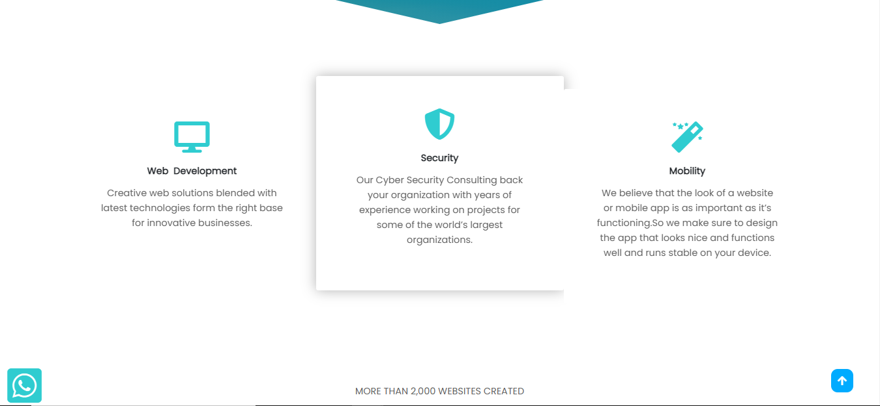

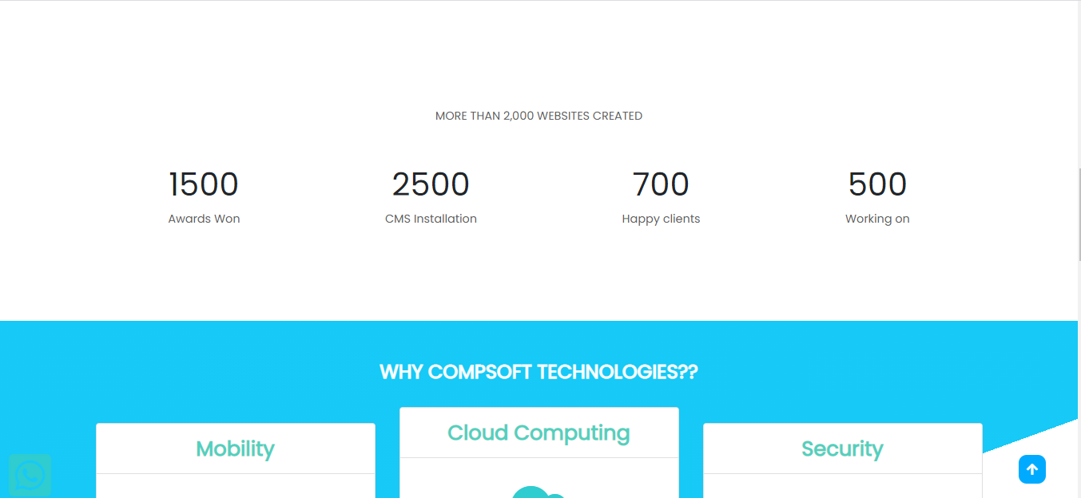

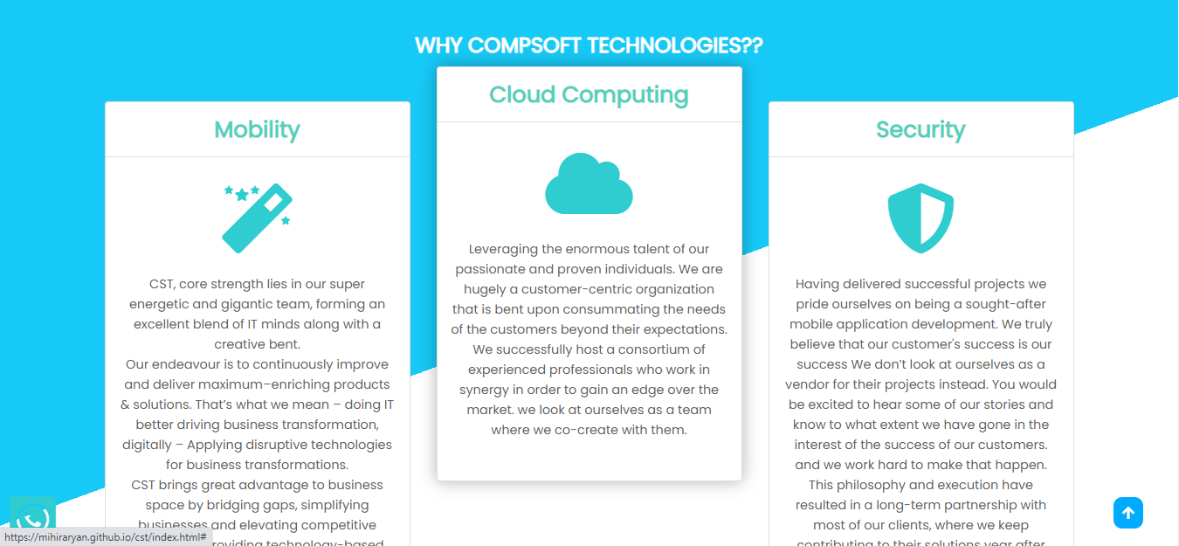

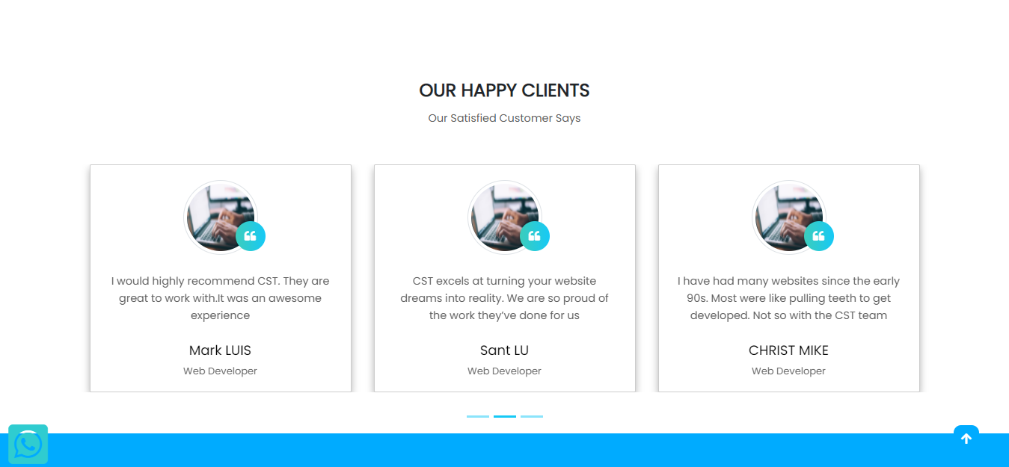

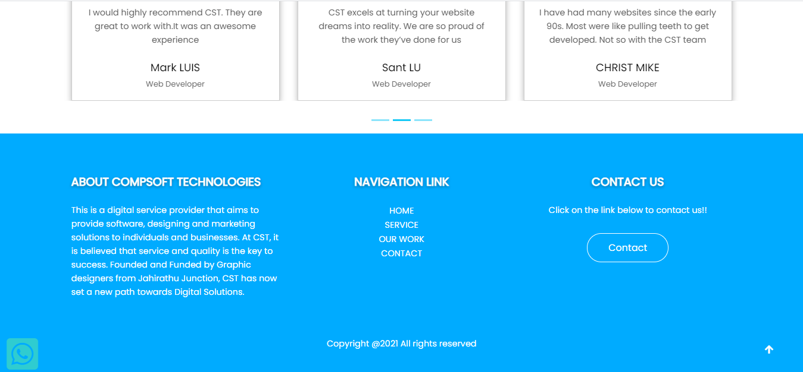

# SERVICE PAGE

# 

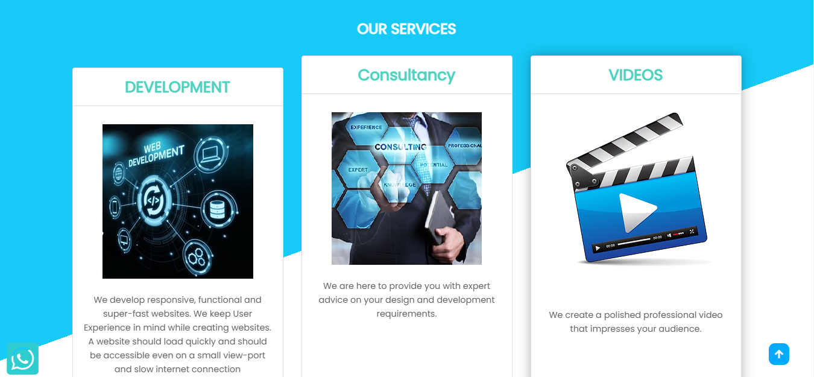

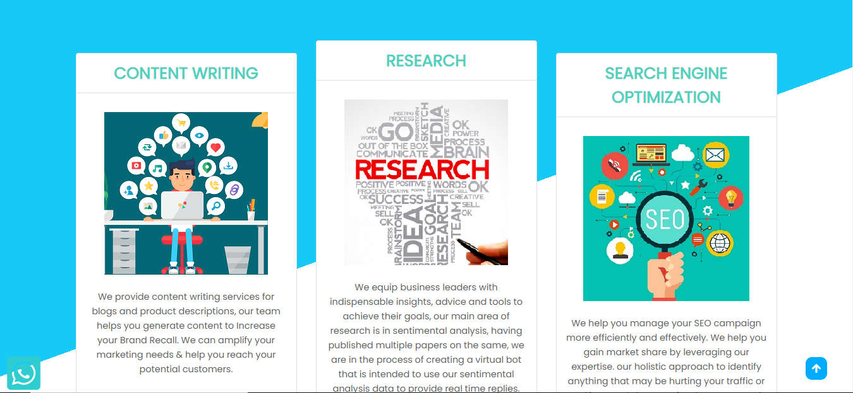

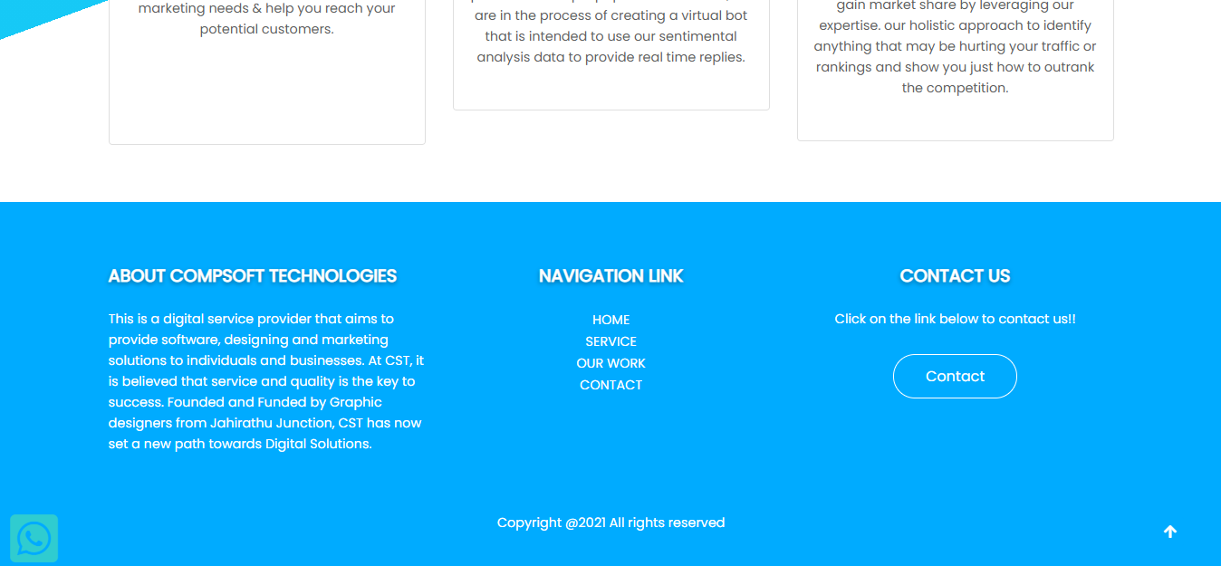

# WORK PAGE

# 

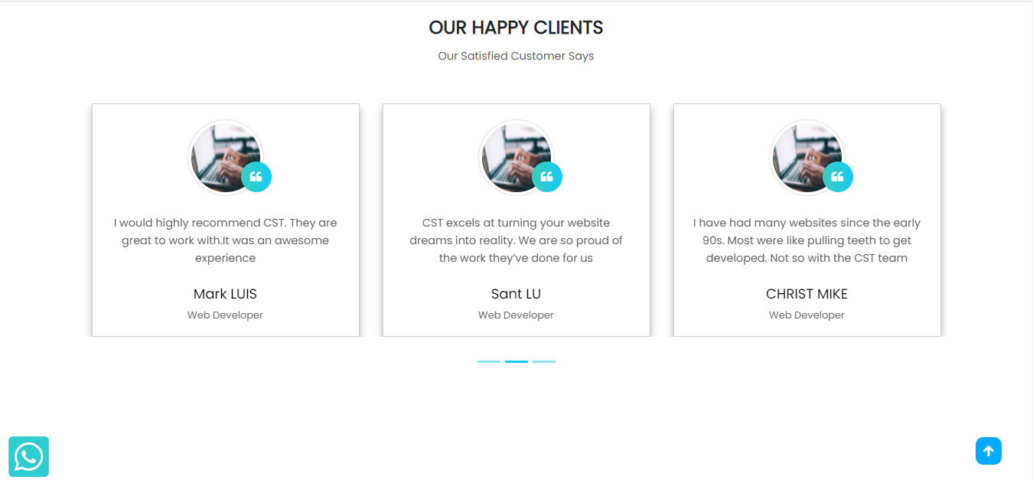

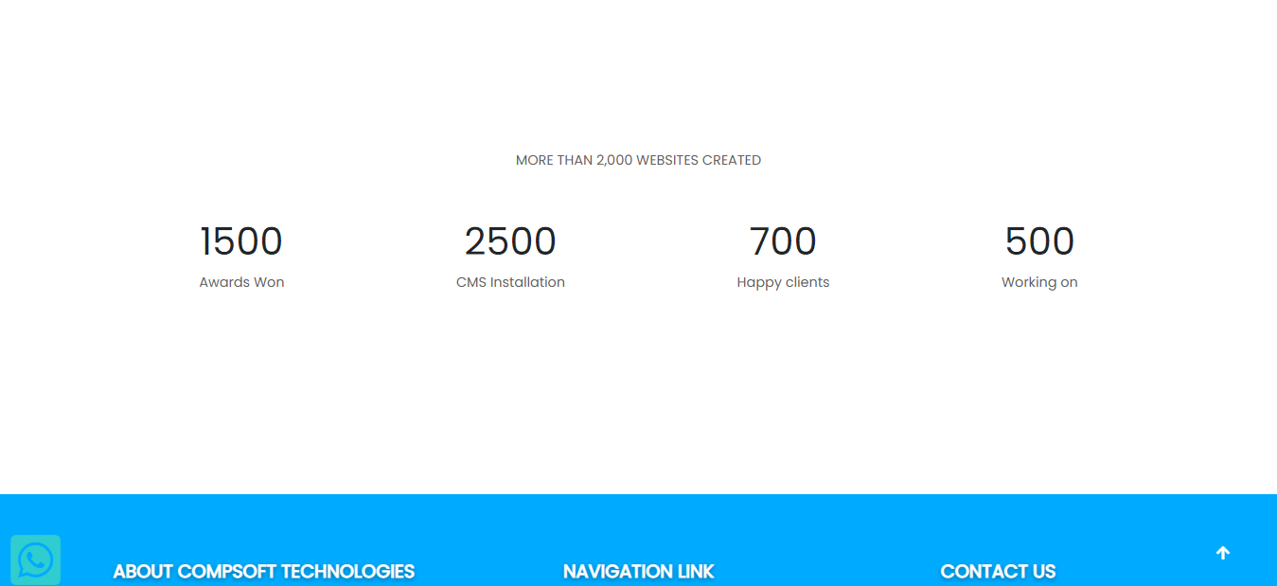

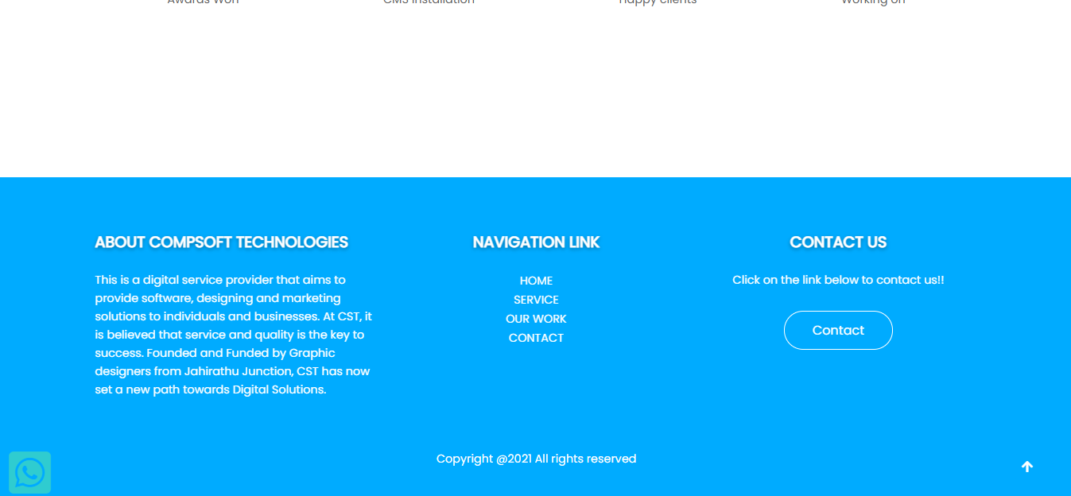

# CONTACT PAGE

# 

# 

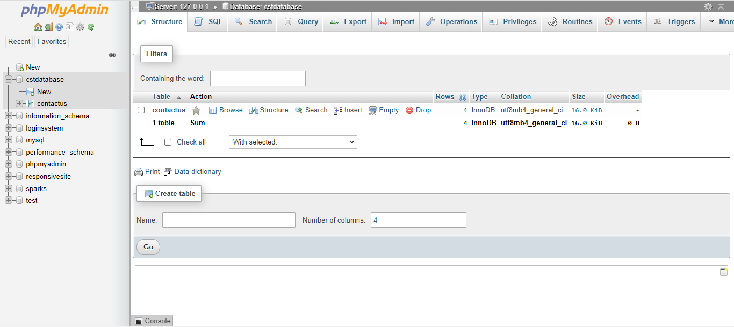

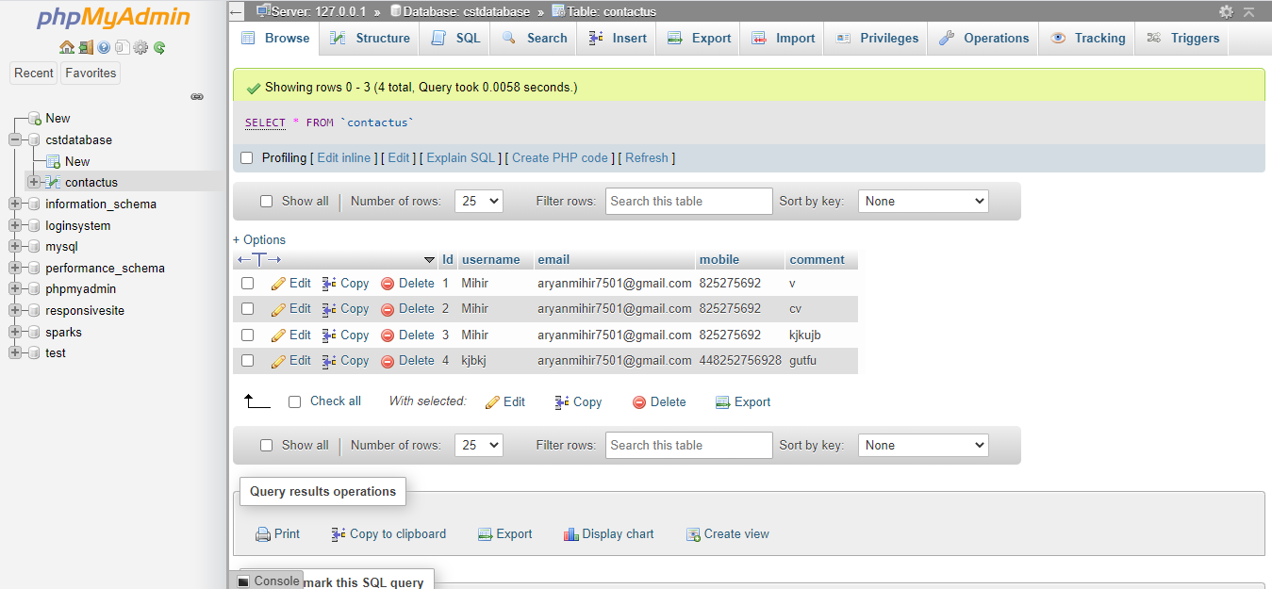

**BIBLIOGRAPHY**

* https://[www.w3schools.com](http://www.w3schools.com/)
* https://[www.geeksforgeeks.org](http://www.geeksforgeeks.org/)
* <https://freefrontend.com>
* Youtube

## About my TEAM

MEMBER 1: NEHAL MODI (TEAM LEADER)

MEMBER 2: MIHIR ARYAN

Both the members of the team worked together in the following areas for the successful completion of the project:

* FRONT END (HTML,CSS,JAVASCRIPT)
* BACK END(PHP,MY SQL)
* REPORT MAKING